VISUALIZATION TOOL FOR ELECTRIC VEHICLE CHARGE AND RANGE ANALYSIS

Project Based Experiential Learning Program

# INTRODUCTION:

# The Electric Vehicle (EV) is not new, but it has been receiving significantly more attention in recent years. Advances in both EV analytics and battery technologies have led to increased automotive market share. However, this growth is not attributed to hardware alone. The modern mechatronic vehicle marries electrical storage and propulsion systems with electronic sensors, controls, and actuators, integrated closely with software, secure data transfer, and data analysis,to form a comprehensive transportation solution. Advances in all these areas have contributed to the overall rise of EV’s, but the common thread that runs through all these elements is data analytics.

# TABLEAU:

# Tableau was found in 2003 to enrich the business but I become one the business strategy. As the market leading choice for modern business platform makes it easier to explore and manage data and faster to discover and share insights that can business and the world.

# PROBLEM UNDERSTANDING:

# I understood the business requirements for analyzing the performance and efficiency of Electric cars includes identifying KPIs, comparing performing across different parameters and brands also, identifying patterns and trends over time, identifying affecting factors and then I got an idea to rectify the problem.

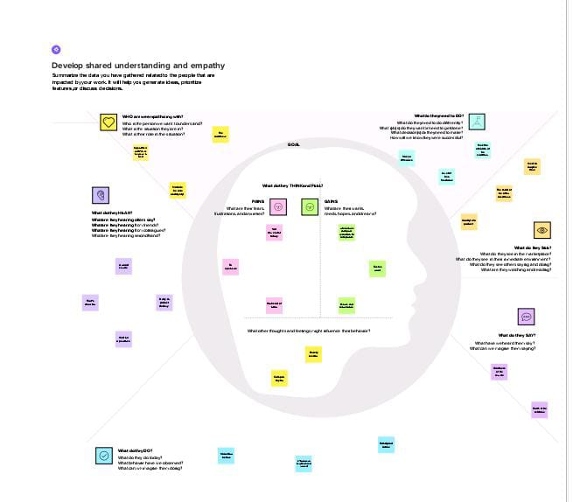

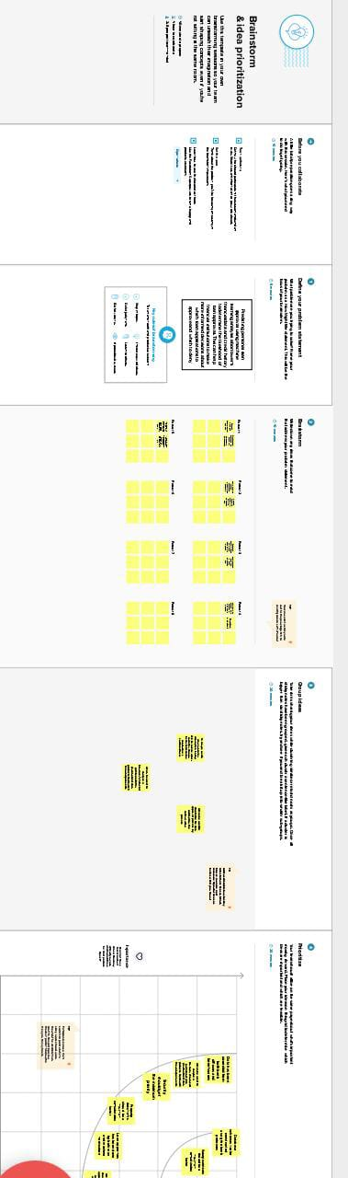

# DATA COLLECTION:

# Data collection is the process of gathering and measure information on variables of interests, in an established systematic fashion that enables one to answer stated research questions. It contains all the meta information regarding the columns described in the 4 CSV files. They are EV India, Electric vehicle charging station list, Electric car data clean, Cheapest electric cars database and they are in the form of excel. It shows the cars model, brand, regions of the charging station etc…

# DATA PEPARATION

# The data preparation helps to make the data easily understandable and ready for creating visualizations to gain insights into the performance and efficiency. Here we prepared the data by using tableau software which is easily understood and useful for the one, who is interested to study about electric charging vehicles.

# DATA VISUALIZATION

# Data visualization is the process of creating graphical representations of data in order to help people understand and explore the information. Visualization data are in the form of charts such as bar charts, pie charts, graphs and maps. The charts represent the car model, trends, patterns, prices, region where the charging stations are available in India. It is to make the complex data sets as easier to interpret.

# RESULT:

# The following images showed that, there are different models available in EV cars, Car brands are in various states, price rate, top speed of EV cars etc…

# ADVANTAGES OF EV CHARGING:

# According to global electric vehicle trend, charging infrastructure is gradually increasing. Hyundai Motor Group has also developed a wireless charging system upon today’s trend and existing wire charging stand turns into a converter while the plug is replaced by a magnetic path. It’s a wireless charging system with similar mechanism to an induction stove. In the foreign countries, charging system is available in the parking area at the time of parking, the cars are easily charged by the technology.

# DISADVANTAGES OF EV CHARGING:

# EV cars are not easily charged because the charging stations are not available easily. The distance between one station to another is too long. It is the only drawback of EV cars but now a days, the charging stations also be constructed in particular kilometers. The charging stations are mentioned in the pie charts.

# CONCLUSION:

# From this project, we can understand about the tableau software briefly and also understand about the EV cars. Tableau software gives the 4 CSV files in the form of charts, maps etc. In the project, we created the story which says about EV charging stations, models, brands, price rate etc.. Tableau can able to bring the revolution of the business world.